**CSC 430 Software Engineering**

**Professor Zhanyang Zhang**

Spring 2012

**Software Requirements Document**

**Document Specification**

**Amanda Stefanese, Ahmed Mahmoud, Travis Khan, & Joe Skinner**

Table of Contents

1. Preface 4

1.1. Modification History 4

1.2. Intended Audience 4

2. Introduction 4

2.1. Purpose of the requirements document 4

2.2. Reference 4

2.3. Overview of the reminder of the document 5

3. Glossary 5

4. System Requirements Specification 5

5. System Models 8

5.1. Use Case Diagram 8

5.2. Sequence diagram 9

6. System Evolution 10

**Table of Figures**

Figure 1. User Case Diagram 8

Figure 2. Staff Case Diagram 9

Figure 3. Browser Sequence Diagram 9

Figure 4. Desktop Application Sequence Diagram 10

# Preface

The expected readership of the document is the students who join the site and want to learn more about the intricacies.

V 0.1 -Initial Release

-Users can chat with each other via their Whiteboards.

-Ability to upload photos and view yours and your friend’s photos

V 0.2-Updated interface

V 0.3-Bug fixes and creation of messaging service

V 0.4-Added About Me and favorites

V 0.5-More Bug fixes and streamlined code

V 0.5-Added thumbnails instead of resizing full size image

## Modification History

|  |  |  |  |
| --- | --- | --- | --- |
| Date | Version | Author | Summary of changes |
| 4/6/2012 | V1.0 | Amanda Stefanese | 1st Draft of Document |
| 5/22/12 | V2.0 | Amanda Stefanese | 2nd Draft of Document |

## Intended Audience

Our intended audience for Social Mutiny is for anyone who enjoys connecting with other users through the internet by chat and photos. Majority of our intended audience will be teens and young adults because they consume a mass amount of their free time using the internet and cell phones.

# Introduction

The function of the system is to bring students closer together, to give them the ability to collaborate online, easily, in real time.

## Purpose of the requirements document

The purpose of this requirements document is to describe the over view of the product and the breakdown for its functionality.

## Reference

Our references for this document and our software are all other social media websites.

## Overview of the reminder of the document

The overview of the remainder of the document is to describe the inner workings on the behalf of the users and the developers. Also, to discuss how the requirements of each interact with each other along with their descriptions.

# Glossary

Here is a definition of some technical terms used in this document.

|  |  |
| --- | --- |
| Term | Meaning |
| Product users | These are users who interact with the system directly. For instance, employees- supervisors, project managers, project engineers and admin. |
| User Requirements | The mandatory details needed to use the service. |
| System Requirements | The needed applications to properly operate and perform the workings of the software. |
| Case Diagrams | A diagram that describes the interactions between a role and the system. |
| Sequence Diagram | A diagram the shows the step-by-step detail of the software interactions. |

# System Requirements Specification

The following list is our functional requirements and their descriptions:

Registration

* User can register by using their email, choosing a password, and confirming their password

Sign In

* Users already enrolled can sign in by using their email and password. They also have a remember me function which will sign the user in automatically without inputting their information.

Profile

* Profile is made up of User Information and Posts.
  + User Information
    - User information is a collection of semi personal information such as the user’s First & Last names, age, profile image (.jpg and .gif)
  + Posts
    - A user can post on their profile by updating status, uploading photos, and posting white board posts.

Settings

* Users can adjust their settings
  + Account Setting
    - In account settings users can change their user name, email address, and password.
  + Privacy Settings
    - In privacy settings uses can edit their search-ability (who can search them in the search bar), Change their audience, (who can view their page), and block other users from viewing or searching their profile.
  + Chat Settings
    - In chat settings users can edit filters to limit the people can chat with them. They can choose a stay logged on setting and they can also block other users from chatting with them.

Search

* Users can search for other users in the search bar by first name, last name, or first and last name together.

Private Messaging

* Users can private message other users. Unlike chat private messaging is not in real time.

Log Out

* With this option users can log out of their account, which closes their profile and chat, and they can no longer access their settings.

Next we discuss our non-functional requirements. We have listed them below:

Database

* The database will hold all user information; such as, passwords, email, pictures user information, etc.

Server

Internet Connections

* All platforms must have an internet connection in order to use our software i.e. Windows Desktop Application, Web Browser

Cookies

* Cookies must be enabled on the user’s device in order to make browsing a better experience and so they can use the “remember me” function.

Web Cache

# System Models

Below are two system models that show the relationships between the system components and the system and its environment. They are a use case diagram and a sequence diagram.

## Use Case Diagram

The use case diagram represents the relationships between the user and developers with the system and its components.

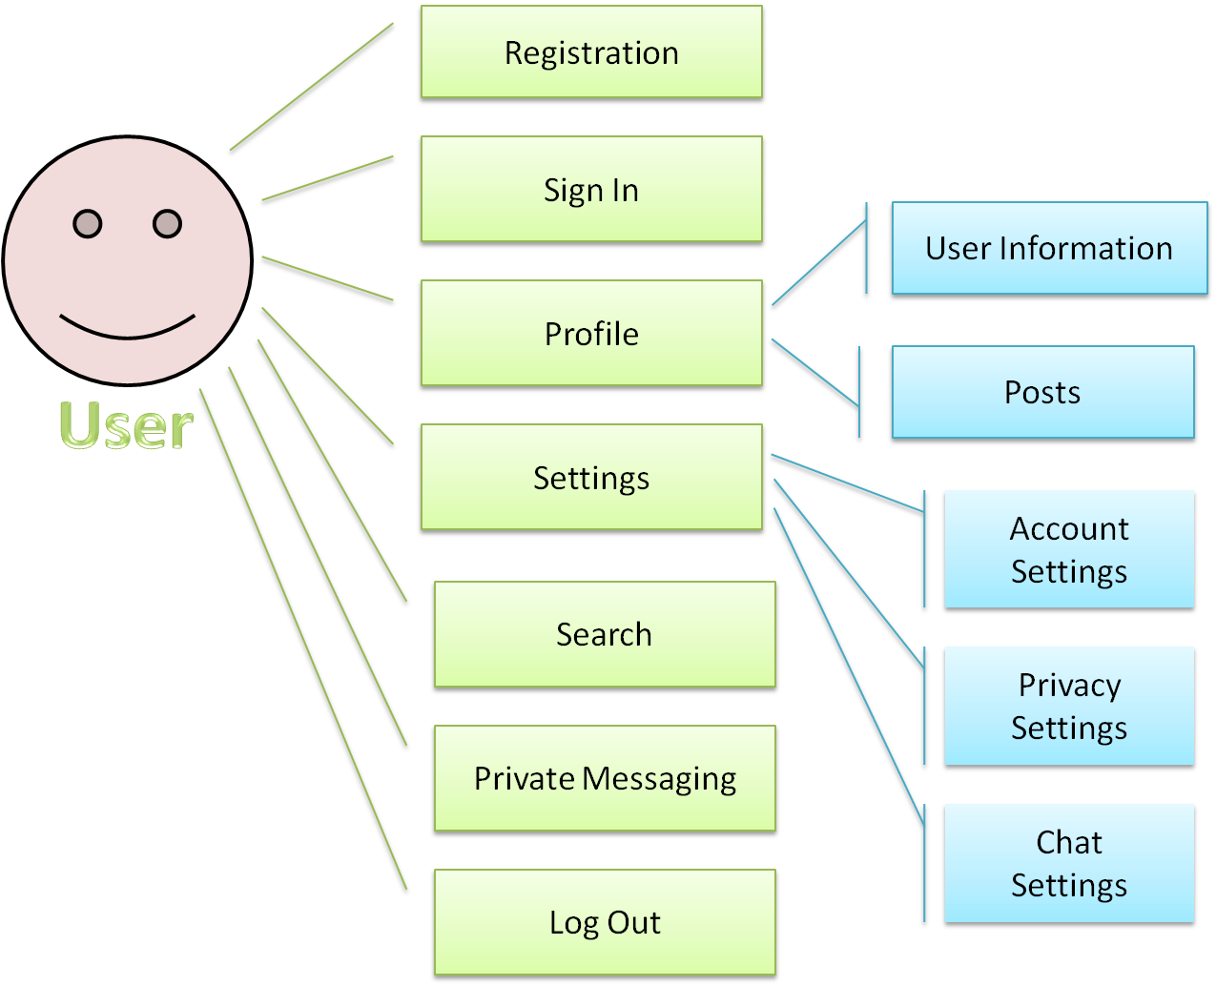

Figure . User Case Diagram

This diagram displays the relationship between the user and the system components that he or she will interact with and use to develop their relationship to our software.

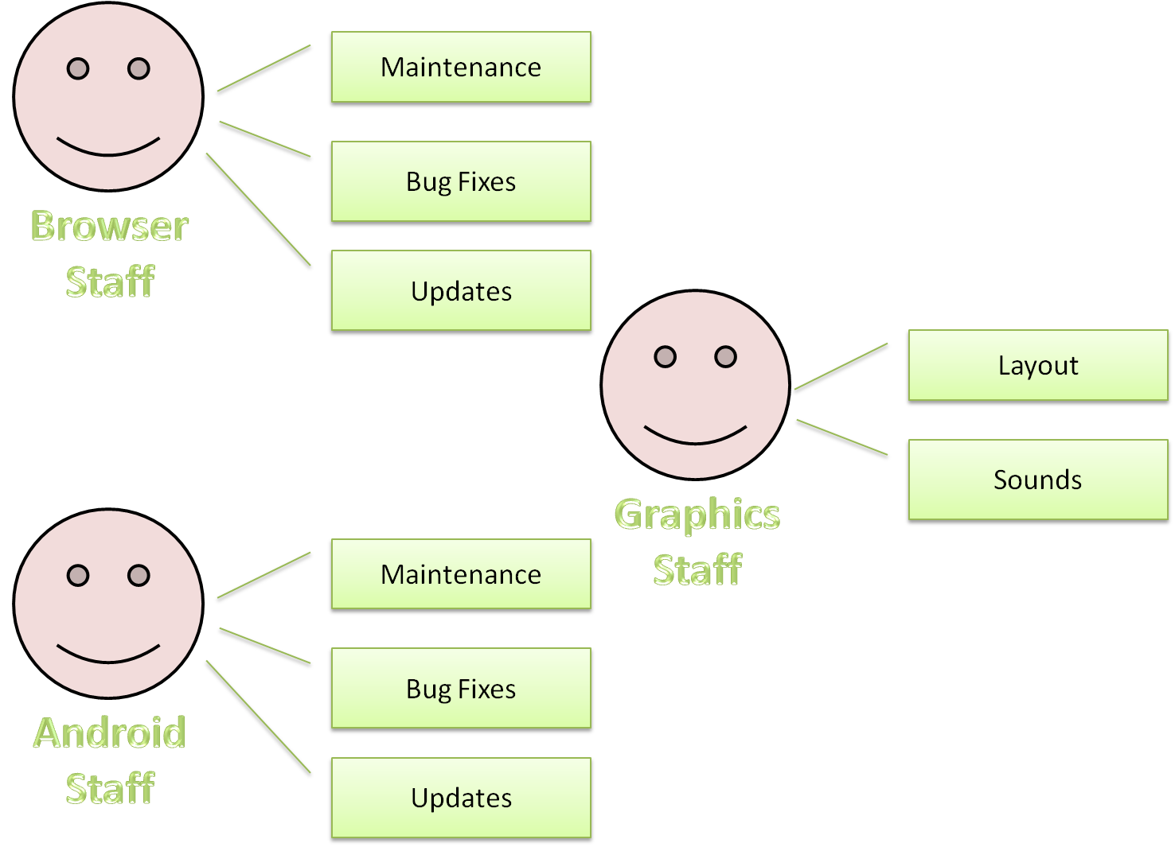

Desktop

Figure . Staff Case Diagram

This diagram displays the way our staff interacts with the system components and depending on their role what components they will specifically using.

## Sequence diagram

The sequence diagrams display the way the system components interact with each other.

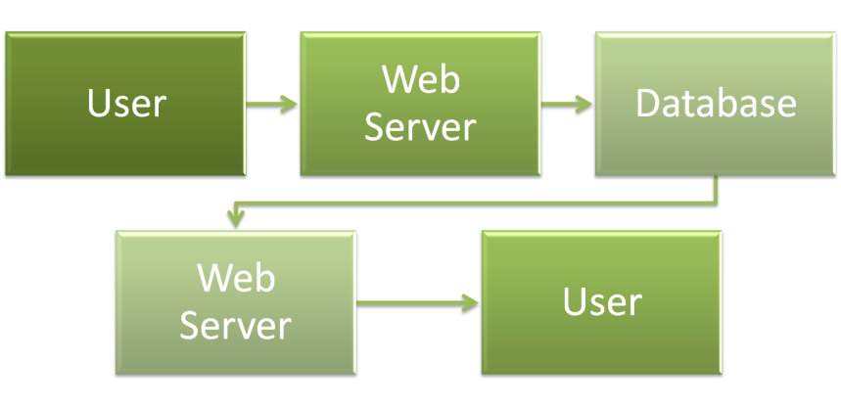

Figure . Browser Sequence Diagram

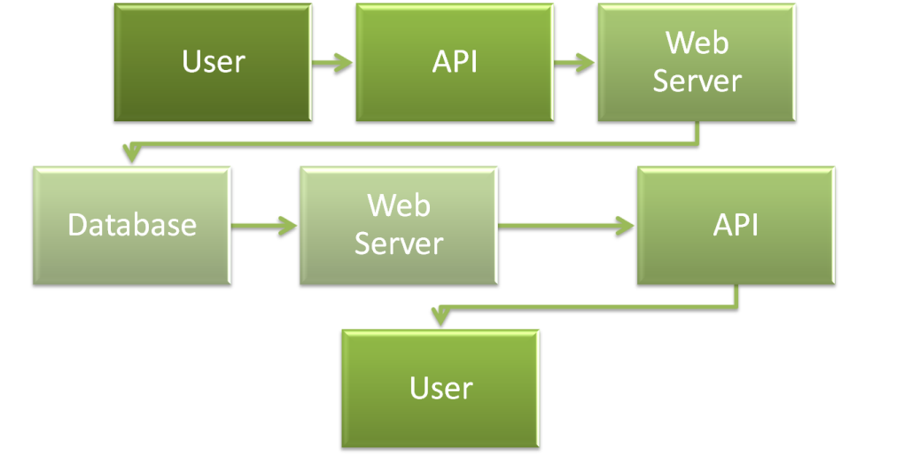

Figure . Windows Desktop Application Sequence Diagram

# System Evolution

As our audience gets bigger, we will start to develop ways for our system to expand with our users. In the future we plan expand our database to make sure it can handle the amount of registered users and their information that we are expecting to have. We also plan to design an IPhone and IPad Application and a Desktop Application for Mac, when we feel the popularity and user-ship of our website has expanded. Along with introducing our software to different platforms we will develop support for them assuming there is ever an issue for the user. Lastly we will try to create a faster connection and upgrade our interface regularly.